DEALS TO HAWAII

Hawaii is synonymous with tropical breezes, juicy pineapples and brilliant sunsets. This island state is a favorite vacation destination, or if you’re very lucky, a fantastic place to go for a work trip. Book a trip to Hawaii via Honolulu International Airport or Maui Kahului International Airport on Virgin America. Fly in style with food, drinks, and movies on-demand.

(MARKET IMAGE HERE)

Find Deals From These Cities

INSERT FARE GRID FROM / TO Version (if available!)

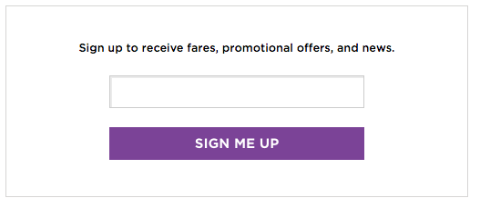

Top Things To Do in Hawaii

If you’ll be visiting Hawaii, you’re undoubtedly trying to figure out which Hawaii activities to put on your must-do list. After all, the Hawaiian Islands offer a plethora of amazing activities, making it overwhelming to narrow down your choices! When planning what to do in Hawaii, you’ll want to make sure you don’t miss out on the experiences below.

* Hawaii is known for its rugged landscapes dramatically dropping into picture-perfect beaches. Each island has its own flavor and top attractions but all feature a fabulous combination of scenic beauty and adventure. Oahu is home to the only major city (Honolulu), Kauai is a nature-lover’s paradise, Lanai is known for fantastic snorkeling, Maui has the impressive Mt. Haleakala and Molokai has a fascinating history in its many acres of protected land.
* Take a snorkeling tour and enjoy the breathtaking beauty of a wide array of native marine life. From tropical fish to the Green Hawaiian Sea Turtle, there are plenty of wonderful surprises in store.
* Go to (and participate in) a luau. Don’t get caught up trying to decide which luau style is the best - just pick one and have fun!
* Try new foods at a Hawaii farmers market. You won’t have any difficulty finding one, as there are many that take place every week all throughout Hawaii. Delight in the abundance of delicious tropical fruits, fresh seafood, honey, coffee, tropical flowers, various arts and crafts from vendors, and much more.

Travel Tips and Resources

[Must-Dos in Hawaii](http://www.bestplaceshawaii.com/tips/10_best/things_to_do.html)

[Hawaii Hotelshttp://www.tripadvisor.com/Hotels-g28932-Hawaii-Hotels.html](http://www.tripadvisor.com/Hotels-g28932-Hawaii-Hotels.html)

[Hawaii Restaurantshttp://www.tripadvisor.com/Restaurants-g28932-Hawaii.html](http://www.tripadvisor.com/Restaurants-g28932-Hawaii.html)

[Hawaii Shopping Guidehttp://www.hotels.com/articles/ar001687/hawaii-shopping-guide-find-where-and-what-to-shop-and-buy](http://www.hotels.com/articles/ar001687/hawaii-shopping-guide-find-where-and-what-to-shop-and-buy)

[Hawaii Nightlife and Entertainmenthttp://www.frommers.com/destinations/hawaii-the-big-island/793930](http://www.frommers.com/destinations/hawaii-the-big-island/793930)

[Hawaii Travel Tipshttp://www.travelsmarthawaii.com/en](http://www.travelsmarthawaii.com/en)

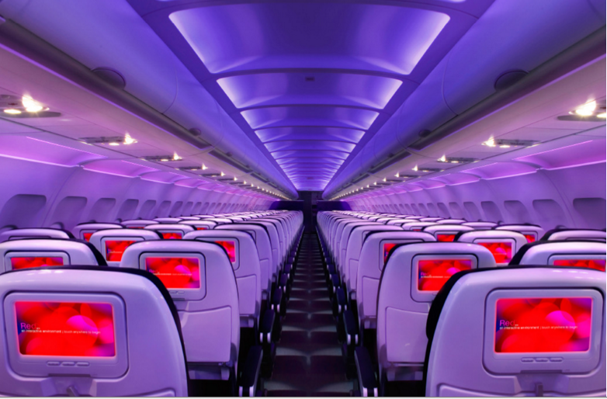

Main Cabin Main Cabin Select First Class

(add links to Cabin Class Pages)

Ready. Set. Fly.

Book your Mood-lit Ride to Hawaii.

Visiting Hawaii and looking for the best flights? Then book your trip to Honolulu International Airport or Maui Kahului International Airport with Virgin America today. Experience our outstanding customer service and state-of-the-art amenities, which include super comfortable leather seats, on demand food ordering, and mood-lit cabins - just to name a few.

Take a Virtual Tour

Add Terms & Conditions